Q7 – Diagnose, Redesign and Validate 13MarksBloom’s Level: K5 – Evaluate
CSA09 – Programming in Java – Assignments CO1–CO5 | Page 8
Review the evidence you generated while working on Q1–Q6. Select ONE solution that showsasignificant limitation as the data size, usage pattern or requirement changes.
You are not permitted simply to replace one collection with another and state that it is faster. Youmust understand the problem first and then develop an appropriate redesign.
A. Diagnose the Bottleneck – 2 Marks
Using your own evidence, identify:
• Where most of the time or memory is spent
• Which operation grows significantly as the data increases
• Whether work is being unnecessarily repeated (for example: re-sorting, re-creatingstrings, linear searches)
• Which characteristic of the chosen class causes the limitation
Evidence Expected
A precise diagnosis supported by evidence from your original implementation. B. Define the Design Objective – 2 Marks
State what your redesign must achieve, for example:
• Reduce repeated object creation
• Avoid scanning the whole collection
• Keep data in the required order without re-sorting
• Reduce memory usage
• Preserve correctness of equality and ordering
Specify a measurable objective wherever possible.
Evidence Expected
A clearly stated redesign objective derived directly from the identified limitation. C. Design the Revised Solution – 4 Marks
Develop a revised solution and explain:
• What you have changed
• Which property of the new class or structure you exploit
• Which operations are avoided or reduced
• Whether additional memory or preprocessing is required • Any new trade-offs created
Provide an appropriate design representation (class diagram or pseudocode). Marks arebasedon the quality of the reasoning, not on naming a known class.
Evidence Expected
A coherent redesign directly addressing the diagnosed bottleneck, with justification. D. Predict Before Implementing – 1 Mark
Predict how the behaviour of the redesigned solution should differ, and the measure in whichyouexpect improvement.
Evidence Expected
A clear, testable prediction made before experimental validation.
CSA09 – Programming in Java – Assignments CO1–CO5 | Page 9
E. Implement and Validate the Redesign – 2 Marks
Implement the redesign and compare Original Solution → Redesigned Solution usingthesame test conditions and suitable measures (time, operations, objects created, memory).
Evidence Expected
Comparable experimental evidence for the original and redesigned solutions. F. Defend the Final Design – 2 Marks
Evaluate whether the redesign achieved its objective. Discuss:
• Whether the prediction was supported
• The magnitude of improvement, if any
• New costs or trade-offs
• Situations in which the original solution may still be preferable
A redesign that does not outperform the original will not automatically be consideredunsuccessful if you correctly analyse and explain why.
Evidence Expected
A critical, evidence-based evaluation and a defensible final engineering conclusion
ANSWER:

public class Main {

static final int TICKETS = 10000;
static final int FIELDS = 50;

static volatile long resultHolder;

// Original approach: String concatenation
static long generateWithString() {
long checksum = 0;

for (int i = 0; i < TICKETS; i++) {
String ticket = "";

for (int j = 1; j <= FIELDS; j++) {
ticket += "Field" + j + ":Value" + i + " ";
}

checksum += ticket.length();
}

resultHolder = checksum;
return checksum;
}

// Redesigned approach: StringBuilder
static long generateWithBuilder() {
long checksum = 0;

for (int i = 0; i < TICKETS; i++) {
StringBuilder ticket = new StringBuilder();

for (int j = 1; j <= FIELDS; j++) {
ticket.append("Field")
.append(j)
.append(":Value")
.append(i)
.append(" ");
}

checksum += ticket.length();
}

resultHolder = checksum;
return checksum;
}

static long measureString() {
long start = System.nanoTime();
generateWithString();
return System.nanoTime() - start;
}

static long measureBuilder() {
long start = System.nanoTime();
generateWithBuilder();
return System.nanoTime() - start;
}

public static void main(String[] args) {

System.out.println("Q7 - REDESIGN VALIDATION");
System.out.println("------------------------------");
System.out.println("Tickets: " + TICKETS);
System.out.println("Fields per ticket: " + FIELDS);

// Warm-up
generateWithString();
generateWithBuilder();

long stringTotal = 0;
long builderTotal = 0;

int repetitions = 5;

for (int i = 0; i < repetitions; i++) {
stringTotal += measureString();
builderTotal += measureBuilder();
}

long stringAverage = stringTotal / repetitions;
long builderAverage = builderTotal / repetitions;

System.out.println("\nAVERAGE EXECUTION TIME");
System.out.println("String: " + stringAverage + " ns");
System.out.println("StringBuilder: " + builderAverage + " ns");

double improvement =
((double)(stringAverage - builderAverage)
/ stringAverage) * 100;

System.out.printf(
"Performance improvement: %.2f%%\n", improvement
);

// Verify that both approaches produce the same result
long originalResult = generateWithString();
long redesignedResult = generateWithBuilder();

System.out.println("\nCORRECTNESS CHECK");
System.out.println("Original checksum: " + originalResult);
System.out.println("Redesigned checksum: " + redesignedResult);
System.out.println(
"Same output length: " +
(originalResult == redesignedResult)
);

System.out.println("\nTESTING COMPLETED");
}
}
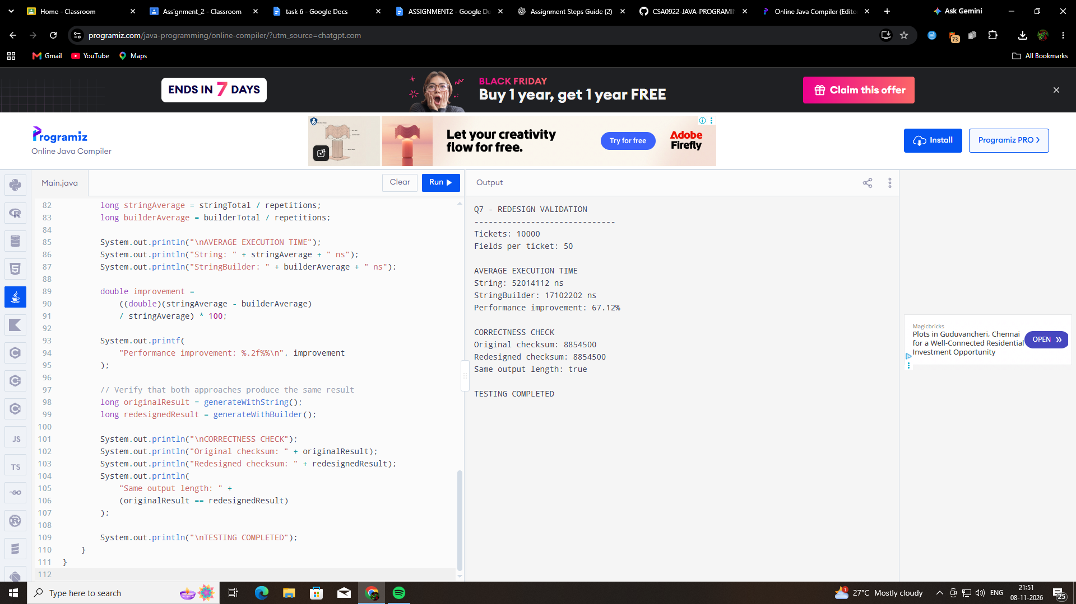

Q7 – Diagnose, Redesign and Validate

A. Diagnose the Bottleneck (2 Marks)
The original ticket-generation implementation used String concatenation (+) repeatedly inside a loop.
Since Java Strings are immutable, every concatenation creates a new String instead of modifying the existing String. This causes repeated object creation and copying of previously generated content.
The limitation becomes more significant when the number of tickets and fields increases.
In the redesigned experiment, the original String approach took an average of 52,014,112 ns to generate 10,000 tickets containing 50 fields each.

B. Define the Design Objective (2 Marks)
The objective is to reduce execution time and unnecessary intermediate String creation while maintaining the same generated ticket content.
The measurable target is to improve performance when generating 10,000 tickets with 50 fields per ticket.

C. Design the Revised Solution (4 Marks)
The original implementation used String concatenation inside nested loops.
The revised implementation uses Java's StringBuilder class and its append() method.
Changes made:
- Replaced repeated String concatenation with StringBuilder.
- Used append() to add ticket fields.
- Created one StringBuilder for each ticket.
- Kept the same number of tickets and fields for a fair comparison.
Property used:
StringBuilder is mutable. It allows characters to be appended to an existing buffer without creating a new String object for every concatenation.
Pseudocode:
Original:
- For each ticket:
- Start with an empty String.
- Repeatedly concatenate each field.
- Store the completed ticket.
Redesigned:
- For each ticket:
- Create a StringBuilder.
- Append each field to the builder.
- Calculate the completed ticket length.
Trade-offs:
StringBuilder uses a mutable buffer and requires additional memory for its capacity. However, it avoids much of the repeated copying associated with String concatenation.

D. Predict Before Implementing (1 Mark)
It was predicted that StringBuilder would perform better than String concatenation for large workloads because it reduces intermediate String creation and repeated copying.
The expected improvement was a reduction in average execution time while maintaining the same output length.

E. Implement and Validate the Redesign (2 Marks)
The original and redesigned solutions were tested using:
- 10,000 tickets.
- 50 fields per ticket.
- One warm-up execution.
- Five measured repetitions.
- Average execution time in nanoseconds.
Experimental Results:
Implementation | Average Time
String | 52,014,112 ns
StringBuilder | 17,102,202 ns
Performance improvement:
67.12%
The redesigned solution was approximately 3.04 times faster than the original solution in this experiment.
The original and redesigned checksums were both 8,854,500, confirming that they generated the same total output length.

F. Defend the Final Design (2 Marks)
The experimental results support the prediction that StringBuilder is more efficient than repeated String concatenation for this large ticket-generation workload.
The redesigned solution reduced execution time by 67.12%.
The main advantage of StringBuilder is that it is mutable and reduces repeated intermediate String creation.
However, StringBuilder requires buffer memory. For small or simple strings, ordinary String concatenation may still be suitable and easier to read.
Final Engineering Conclusion:
StringBuilder is the preferred design for generating large ticket reports containing many fields. It provides better performance for repeated modifications while preserving the generated output length. The experiment demonstrates that choosing the appropriate Java class can significantly improve application performance.

